RTR_GL_INT_009 [1Finance General Ledger to Oracle Fusion Cloud GL]

Interface Overview

Attribute | Value
Interface ID | RTR_GL_INT_009
Source System | 1Finance General Ledger
Target System | Oracle Fusion Cloud General Ledger
Integration Pattern | FBDI (File-Based Data Import)
Middleware | Oracle Integration Cloud (OIC)
Database | Oracle Autonomous Transaction Processing (ATP)
Trigger | REST trigger TriggerParentFBDI

Lean Specification

- Receive a PIPE-delimited journal entry file from 1Finance on HAFT.
- OIC Integration load and transforms into FBDI format and insert into RTR_GL_INT_009_STG (Oracle ATP DB).
- Integration, RTR_GL_INT_009_1FINANCE_FBDI_LOAD_2, is invoked performs COA validation, gets an ERP source ID, and splits data by ledger_id and creates one FBDI zip per ledger (journal data + properties file).
- Submit the zip to Oracle Fusion GL for journal import.
- Import statuses are updated; errors are captured into EMF.

2.1 High-Level Architecture

1Finance GL → HAFT file location → ATP staging → FBDI import → per-ledger FBDI zip → Oracle Fusion Cloud GL

2.2 Overview Diagram
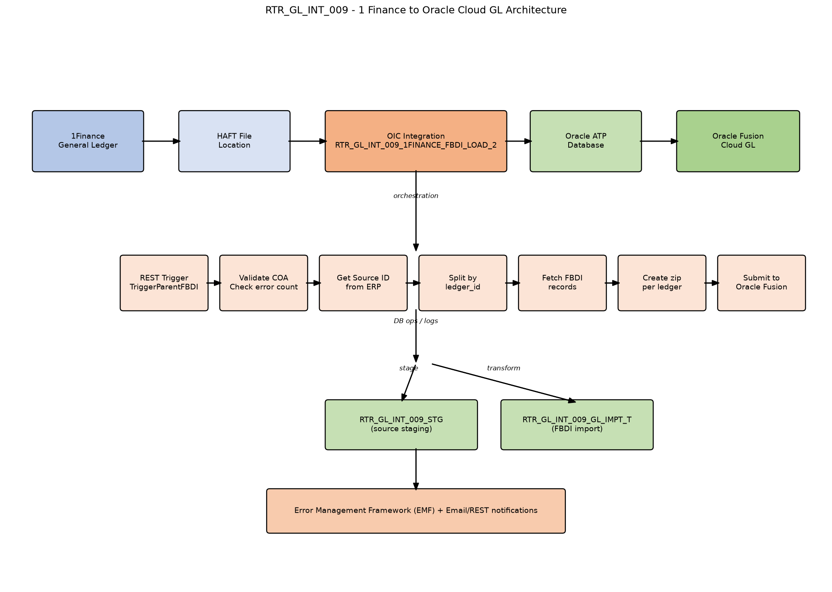

E2E Process Steps with SQL’s

Step | Spec Intent | .iar Component | Connection | SQL Notes
Step 1: Receive Trigger | Initiate the integration | TriggerParentFBDI | RTR_OIC_REST_Connt (REST) | REST trigger. Initial variables assigned.
Step 2: Audit Start | Log the start of the integration run | STARTLOG | OIC Logger | No SQL; calls OIC logger integration.
Step 3: Read File Metadata | Get the source file name from staging | Get_FileName | RTR_ATP_DB_CONN | Get_FileName: select distinct file_name from rtr_gl_int_009_stg where OIC_INSTANCE_ID=#p_OIC_INSTANCE_ID
Step 4: Check COA Mapping Errors | Validate COA mapping before processing | GetProcessingStatus | RTR_ATP_DB_CONN | GetProcessingStatus: SELECT count(*) FROM RTR_GL_COA_MAPPING_STG where oic_instance_id =#oic_instance_id and SUBSTR(TARGET_COA, 5, 1) != '-'
Step 5: Read COA Error Segments | Read invalid COA records for error file generation | ReadCoaErrorSegment | RTR_ATP_DB_CONN | ReadCoaErrorSegment: SELECT <<columns>> FROM RTR_GL_COA_MAPPING_STG where OIC_INSTANCE_ID=#P_OIC_INSTANCE_ID and SUBSTR(TARGET_COA, 5, 1) != '-'
Step 6: Read File Name for Error Output | Get the file name for COA error output | ReadFileName | RTR_ATP_DB_CONN | ReadFileName: select DISTINCT FILE_NAME from RTR_GL_INT_009_STG where OIC_INSTANCE_ID=#poicinstanceid
Step 7: Write COA Error File | Write COA error segment to stage file | WriteCoaErrorSegments | OIC Stage File | No SQL; writes stage file.
Step 8: Email COA Error Notification | Notify on COA validation failure | EmailCoaErrorNotification | RTR_OIC_REST_Connt (REST) | No SQL; REST/Email call. Integration stops after this.
Step 9: Count Source and Stage Records | Count source import and staging records | Get_RecordsCount, GetStageRecordCount | RTR_ATP_DB_CONN | Get_RecordsCount: select count(*) from rtr_gl_int_009_gl_impt_t where oic_instance_id = #P_oic_instance_id ; GetStageRecordCount: select count(*) from rtr_gl_int_009_stg where oic_instance_id = #P_oic_instance_id
Step 10: Get ERP Source ID | Obtain a source ID from ERP for the import | GetSourceID | RTR_ERP_REST_CONN (REST) | No SQL; REST call. Retry loop with vRetryCount / vRetryMaxCount.
Step 11: Get Distinct Ledgers | Identify each ledger to process | DistinctLedgers | RTR_ATP_DB_CONN | DistinctLedgers: SELECT DISTINCT LEDGER_ID, LEDGER_NAME, ACCESS_SET_ID FROM RTR_GL_INT_009_GL_IMPT_T WHERE ((OIC_INSTANCE_ID = #P_OIC_INSTANCE_ID) AND (PROCESS_STATUS = #P_RECORD_STATUS))
Step 12: Get Group ID | Generate or retrieve a group ID for the ledger batch | GetGroupId | RTR_ATP_DB_CONN | GetGroupId: select RTR_GL_INT_009_GROUPID_S.NEXTVAL AS group_id from dual
Step 13: Update Group ID | Store the group ID against the ledger records | Update_Group_Id | RTR_ATP_DB_CONN | Update_Group_Id: UPDATE RTR_GL_INT_009_GL_IMPT_T SET GROUP_ID = #P_GROUP_ID WHERE OIC_INSTANCE_ID = #P_OIC_INSTANCE_ID AND LEDGER_ID = #P_LEDGER_ID
Step 14: Get Ledger Record Count | Count records for the current ledger | GetLederRecordCount | RTR_ATP_DB_CONN | GetLederRecordCount: select count(*) from rtr_gl_int_009_gl_impt_t where oic_instance_id = #oic_instance_id and ledger_name=#ledger_name
Step 15: Get Min and Max Record ID | Determine the batch window for the ledger | GetMinandMaxRecordID | RTR_ATP_DB_CONN | GetMinandMaxRecordID: select max(record_id)max, min(record_id) from RTR_GL_INT_009_GL_IMPT_T where ledger_name=#p_ledger_name and oic_instance_id=#p_instance_id
Step 16: Fetch FBDI Records in Batches | Read FBDI-formatted records in chunks | GetFBDIRecords | RTR_ATP_DB_CONN | GetFBDIRecords: SELECT <<columns>> FROM RTR_GL_INT_009_GL_IMPT_T WHERE LEDGER_ID = #pledgerid and OIC_INSTANCE_ID = #OIC_INSTANCE_ID and RECORD_ID >= #p_start_id and RECORD_ID<=#p_end_id ORDER BY RECORD_ID ASC
Step 17: Create FBDI Import Zip | Build import zip per ledger | Write_FBDI_Files, WritePropertiesFile, Zip | OIC Stage File | No SQL; writes data file, properties file, and zips them.
Step 18: Submit to Oracle Fusion | Import journals into Oracle GL | ERPCall | RTR_ERP_CONN_PUBLIC (Oracle ERP Cloud) | No SQL; submits zip via ERP FBDI service.
Step 19: Update Import Job ID | Track ERP import job ID | Update_JobId | RTR_ATP_DB_CONN | Update_JobId: UPDATE RTR_GL_INT_009_GL_IMPT_T SET LOAD_REQUEST_ID = #P_IMP__REQ_ID, PROCESS_STATUS = 'UPLOADED' WHERE OIC_INSTANCE_ID = #P_OIC_INSTANCE_ID AND LEDGER_ID = #P_LEDGER_ID AND GROUP_ID=#P_GROUP_ID
Step 20: Update Ledger Error Status | Mark ledger import as rejected on ERP error | UpdateTxnTableLedger | RTR_ATP_DB_CONN | UpdateTxnTableLedger: UPDATE RTR_GL_INT_009_GL_IMPT_T SET PROCESS_STATUS='REJECTED-OIC-ERROR' , STATUS_MESSAGE = #STATUS_MESSAGE WHERE OIC_INSTANCE_ID = #oic_instance_id and ledger_id=#p_ledger_id
Step 21: Update Error Status in Staging | Mark source staging records as error | Update_Error_Status_Stg | RTR_ATP_DB_CONN | Update_Error_Status_Stg: UPDATE RTR_GL_INT_009_STG SET PROCESSED_STATUS='ERROR' WHERE OIC_INSTANCE_ID = #oic_instance_id and ledger_name = #ledgername
Step 22: Update Transaction Error Total | Set import table process status to error | ErrorUpdateTxnTbl | RTR_ATP_DB_CONN | ErrorUpdateTxnTbl: UPDATE RTR_GL_INT_009_GL_IMPT_T SET PROCESS_STATUS = #ERR , STATUS_MESSAGE = #STATUS_MESSAGE WHERE OIC_INSTANCE_ID = #oic_instance_id
Step 23: Update Staging Error Total | Set staging process status and error message | ErrorUpdateSTGTabletotal | RTR_ATP_DB_CONN | ErrorUpdateSTGTabletotal: UPDATE RTR_GL_INT_009_STG SET PROCESSED_STATUS='ERROR' ,ERROR_MESSAGE = #ERROR_MESSAGE WHERE OIC_INSTANCE_ID = #oic_instance_id
Step 24: Get Error Record Range | Find min/max record IDs for error output | GetErrorRecordsMinMaxRecordID | RTR_ATP_DB_CONN | GetErrorRecordsMinMaxRecordID: select max(record_id)max, min(record_id) from RTR_GL_INT_009_STG where oic_instance_id=#p_instance_id and PROCESSED_STATUS ='ERROR'
Step 25: Count Error Records | Count records to generate error file | CountOfErrorRecordsFromStgTable | RTR_ATP_DB_CONN | CountOfErrorRecordsFromStgTable: select count(*) from RTR_GL_INT_009_STG where oic_instance_id=#p_instance_id and PROCESSED_STATUS ='ERROR'
Step 26: Fetch Error Records | Read error records for the error file | ErrorRecordsFromStgTable | RTR_ATP_DB_CONN | ErrorRecordsFromStgTable: SELECT <<columns>> FROM RTR_GL_INT_009_STG WHERE OIC_INSTANCE_ID=#POICInstanceID and PROCESSED_STATUS = 'ERROR' and RECORD_ID >= #p_start_id and RECORD_ID<=#p_end_id ORDER BY RECORD_ID ASC
Step 27: Write and Archive Error File | Generate and archive ledger error file | WriteErrorFileForLedger, AppendFooterline, ArchiveLedgerErrorFile | OIC Stage + RTR_OIC_REST_Connt (REST) | No SQL; writes stage file and archives via REST.
Step 28: Global Fault Handler | Catch unhandled exceptions and update fault status | UpdateGblFaluts | RTR_ATP_DB_CONN | UpdateGblFaluts: UPDATE RTR_GL_INT_009_STG SET LAST_UPDATE_DATE=#lud,LAST_UPDATE_BY=#luser,PROCESSED_STATUS = #status,ERROR_Message=#ERR WHERE OIC_INSTANCE_ID = #oic_instance_id
Step 29: Completion | Log end and stop the integration | END_LOG | OIC Logger | No SQL; final log and stop.

Key Tables and Stage Files

Table / File | Purpose
RTR_GL_INT_009_STG | Raw journal data staged from the source file.
RTR_GL_COA_MAPPING_STG | COA mapping validation table.
RTR_GL_INT_009_GL_IMPT_T | FBDI-formatted journal import table.
GL_IMPORT_1FIN_LEDGER_ID_GROUP_ID.zip | Final FBDI zip submitted to Fusion GL.
FBDI data file | Content produced by Write_FBDI_Files.
FBDI properties file | Metadata produced by WritePropertiesFile.
COA error file | Output of WriteCoaErrorSegments.
Ledger error file | Output of WriteErrorFileForLedger + AppendFooterline.

Variables

Variable | Purpose
vSTPFileDirectory, vFilename | Source file location and name
vSourceID | ERP source identifier
vRetryCount / vRetryMaxCount / vWaitTime | Retry control
vMinRecordID / vMaxRecordID / vStartID / vEndID | Batch processing window
Error_flag, vStatusCode, vStatusMessage | Error and status tracking

Error Handling Matrix

Error Scenario | Stage | Components Involved | Action
COA validation fails | Initial | ReadCoaErrorSegment, WriteCoaErrorSegments, EmailCoaErrorNotification | Write error file, email, stop integration
ERP source ID failure | Before ledger loop | GetSourceID, vRetryCount, vWaitTime | Retry up to max; throw fault if exceeded
FBDI import failure | Ledger processing | UpdateTxnTableLedger, Update_Error_Status_Stg, Notification_for_ledge_failure | Update error status, send notification, continue to error file generation
Global fault | Anywhere | UpdateGblFaluts, Notification, GlobalFault_EndLog | Log, notify, re-throw
Post-process error file generation | After import | GetErrorRecordsMinMaxRecordID, WriteErrorFileForLedger, ArchiveLedgerErrorFile | Generate and archive per-ledger error file

Notes

- The integration is REST-triggered, not file-triggered. The source file is likely placed on HAFT and staged in ATP by a separate upstream process.
- All data operations are grouped by ledger_id, and one FBDI zip is generated per ledger.
- Records are processed in batches using vStartID and vEndID windows.
- A retry loop is present for the ERP source ID retrieval.
- Error handling has two levels: initial COA validation that stops the flow, and ledger-level import errors that continue processing and generating error files.

Key Terms

Term | Meaning
FBDI | File-Based Data Import — Oracle Fusion's bulk import mechanism.
HAFT | File server location where source files are placed.
1Finance | Dell's existing Finance/GL system of record (source).
Oracle Cloud GL | Oracle Fusion Cloud General Ledger (target).
ATP | Autonomous Transaction Processing database used for staging and tracking.
COA | Chart of Accounts validation.
OIC | Oracle Integration Cloud.
Source ID | Identifier retrieved from ERP to tag the import batch.
Group ID | Identifier generated per ledger batch to group related records.

